CE211-L Circuit Analysis Lab



Lab Report # 9

Submitted by: Shayan Rizwan Yazdanie [2024585]
Submitted to: Engr. Muhammad Shakaib
Semester: 03

Faculty of Computer Science and Engineering
GIK Institute of Engineering Sciences and Technology

Task Statement:
- Calculate the current (I_{L}) and voltage (V_{o}) across 1kΩ resistor in the given circuit.
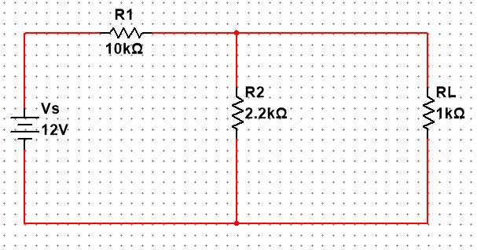

Solution
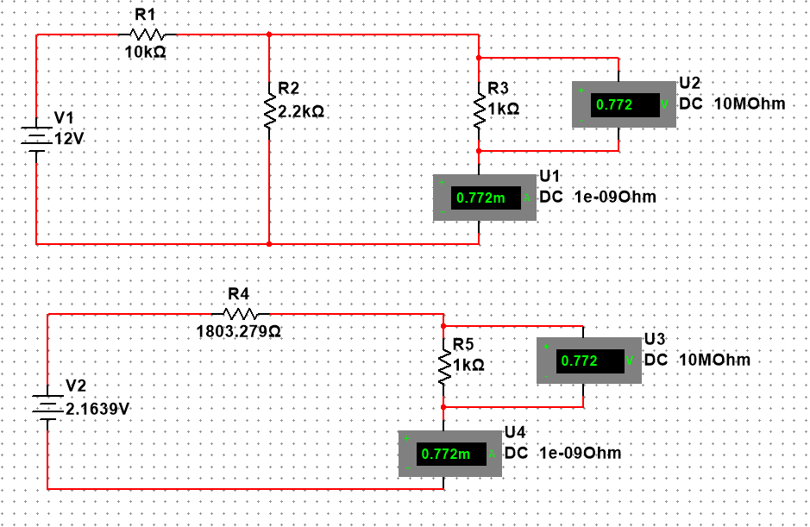

Calculating Thevenin Resistance $R_{TH}$:
$$R_{TH}=R_{1}∥R_{2}$$
$$R_{TH}=\frac{R_{1}⋅R_{2}}{R_{1}+R_{2}} \\ =\frac{10k⋅2.2k}{10k+2.2k} \\ =\frac{22k^{2}}{12.2k} \\ =1803.279 Ω$$

Calculating Thevenin Voltage $V_{TH}:$
Using Voltage divider formula:
$$V_{TH}=V_{s}(\frac{R_{2}}{R_{1}+R_{2}}) \\ =12(\frac{2.2k}{10k+2.2k}) \\ =12(\frac{2.2}{12.2}) \\ { V}_{TH}=2.1639 V$$

Calculating Load Current $I_{L}$:
$$I_{L}=\frac{V_{TH}}{R_{TH}+R_{L}} \\ I_{L}=\frac{2.1639}{1803.279+1000} \\ I_{L}=0.7719\text{ mA}$$

Calculating Output Voltage $V_{o}$:
$$V_{o}=I_{L}⋅R_{L} \\ V_{o}=0.7719×{10}^{-3}×1000 \\ V_{o}=0.7719 V$$

Final Answers:
- Load Current: $I_{L}=0.7719\text{ mA}$
- Output Voltage: $V_{o}=0.7719\text{ V}$

